User Guide

Tello Environment Setup

Indoor Drone Development Project

Supervisor: Mr. Cao Xuan Nam

Date: May 20, 2020

### **ArduPilot (Drone v2.0 and SITL Drone)**

#### Requirements: The source codes are based on python3.7

#### Install initial dependencies

$ python-dev python-opencv python-wxgtk3.0 python-matplotlib python-pygame python-lxml python-yaml vim git

#### Installation manual

1. Using pre-made executable file (for 3 major OS) in [*<Source code/ArduPilot/Notes/Environment setup>*](https://github.com/1659012/RnD16Bit/tree/ArduPilot/Source%20code/ArduPilot/Notes/Environment%20setup) to install basic requirements. 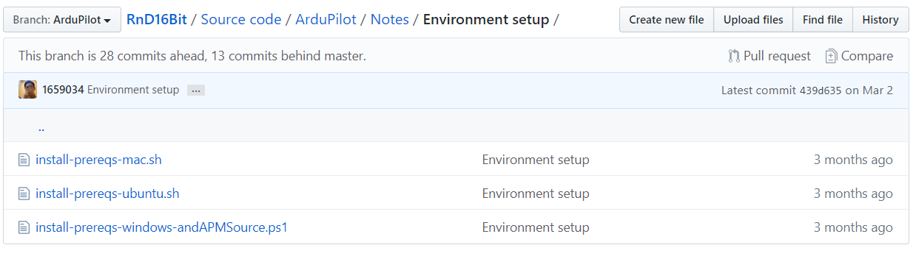
2. (*Recommended*) Install LinuxOS Virtual Machine (Follow these [NOTES](https://github.com/1659012/RnD16Bit/tree/ArduPilot/Source%20code/ArduPilot/Notes/Virtual%20Machine%20setup))
3. Clone the ArduPilot git repository using

$ git clone <https://github.com/ardupilot/ardupilot>

$ cd ardupilot

1. Sub module the repository (*Might take a while)*

$ git submodule update --init --recursive

1. Within Ardupilot folder, navigate into *<Tools/autotest>* and copy the path

$ cd Tools/autotest

$ pwd



1. Modify your <*bashrc*> (system path) file

$ sudo vim ~/.bashrc

$ export PATH="<*your path here>*":$PATH

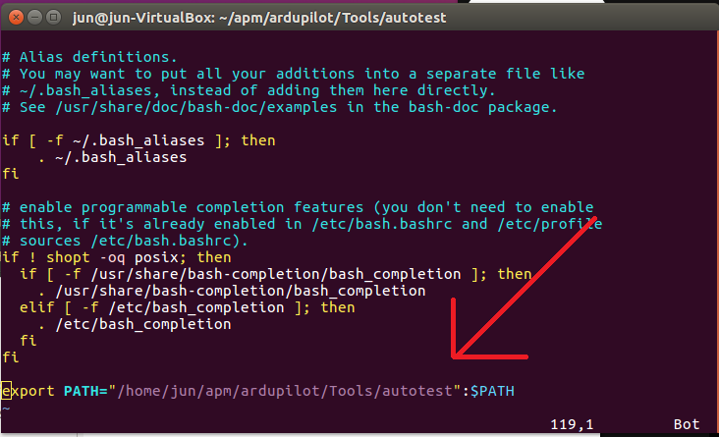

1. $ source ~/.bashrc

To ensure your path is readable by the system

### **Tello**

#### Requirements: The source codes are based on python3.7

<https://dl-cdn.ryzerobotics.com/downloads/Tello/Tello%20SDK%202.0%20User%20Guide.pdf>

#### C:\Users\Admin\AppData\Local\Microsoft\Windows\INetCache\Content.Word\IMG_0897.jpeg

#### Installation manual

1. Make sure python3.7 or above is available and functioning within your system
2. Using the system’s terminal

Install these packages using pip command

$ pip install Flask

$ pip install numpy

$ pip install av

$ pip install opencv-python

$ pip install image

$ pip install pygame

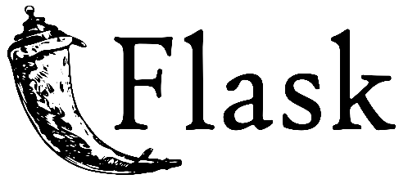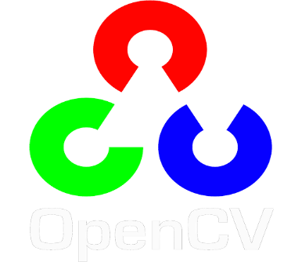

(*Notes: Flask is for local hosting the Web UI using python, OpenCV is an open source library specified in Computer Vision)*

1. Download and install FFMPEG from <https://www.ffmpeg.org/>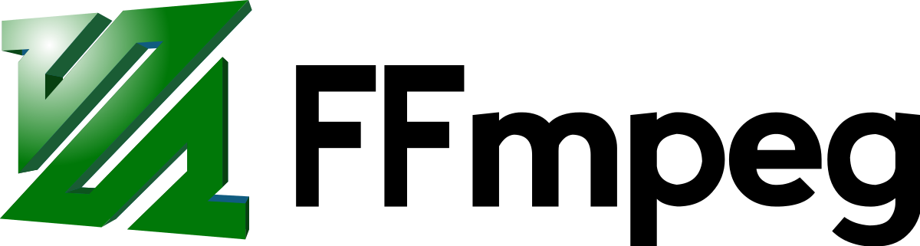

(*Notes: FFMPEG is required to decode the received video data from the drone)*

1. Install PyCharm from <https://www.jetbrains.com/pycharm/> (*PyCharm is a python IDE to control the source paths and executing python codes)* 
2. Open project folder as PyCharm 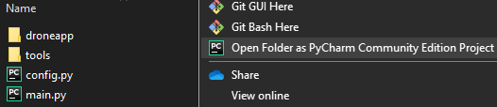
3. Configure python interpreter

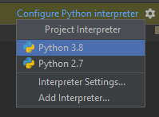

1. Create a run configuration from main.py

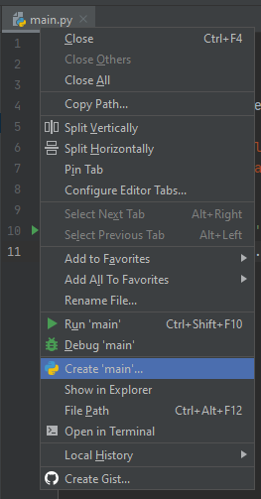 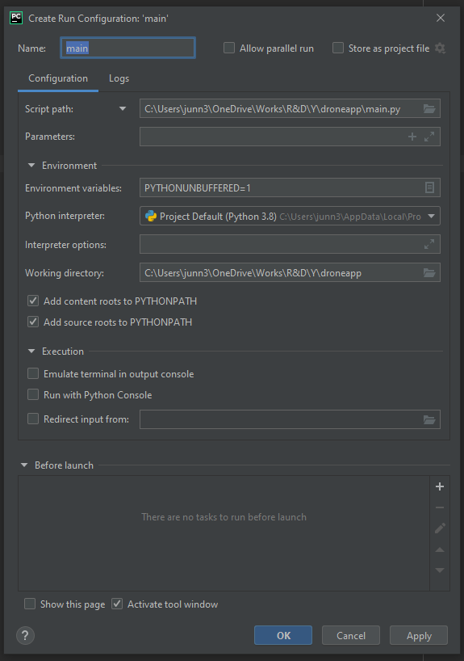

(*Note: Remember to check the “Script path” to be your project path)*